L1 – Student will draw a picture to represent each story element (character/setting).
L2 – Student will draw and label story elements (character/setting/plot).
Characters – Who is in the story?   | Setting – Where? When?  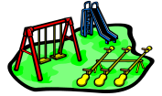

Events, plot – What happened?
First  1 | Next  2 | Then  3 | Last/Finally  4

